Continue setup (centos)

Table of contents:

1. Install Tmux
   1. Overview
   2. Installation setup
2. Install emacs
   1. Overview
   2. Installation setup
3. Install Fail2Ban
   1. Overview
   2. Installation setup
4. Install cowsay
   1. Overview
   2. Installation setup
5. Install lolcat
   1. Overview
   2. Installation setup
6. Update vi to vim
   1. Overview
   2. Installation setup

1. Install Tmux
   1. Overview

Tmux is terminal multiplexer that we can use to open more than one terminal windows in one place and do so many tasks in one place.

* 1. Installation setup
* First, we check if we have the Tmux package in our local repository by typing the command blow:

Sudo dnf search tmux

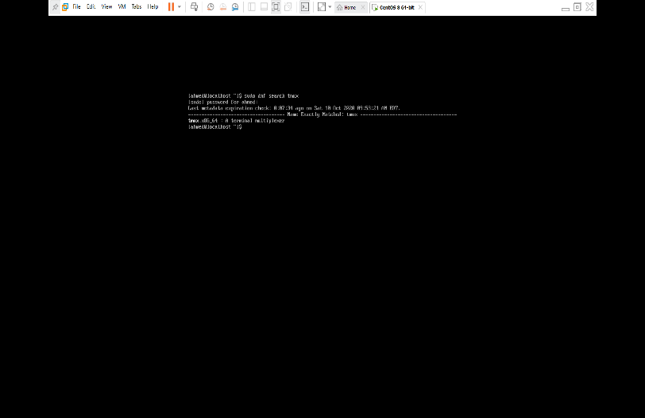

The Tumx package is available.

* Second start the installation by typing the command blow:

Sudo yum install tmux

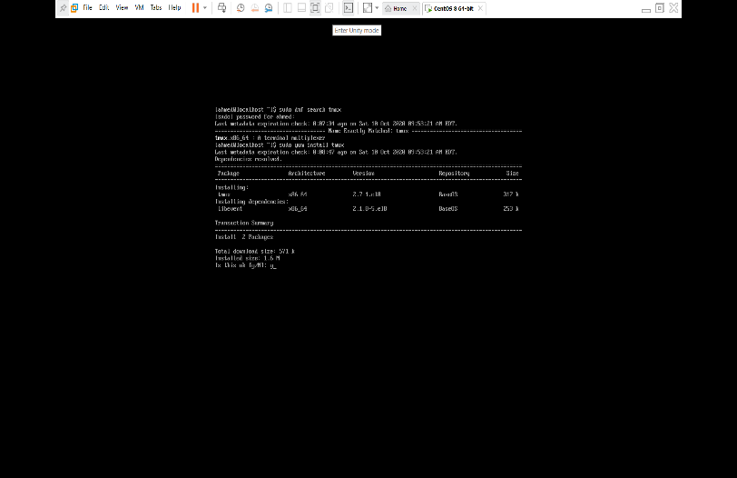

Here they give the summary of the package type yes to continue

* After the installation is done, we check the location of the installed file by typing the command blow:

Which tumx

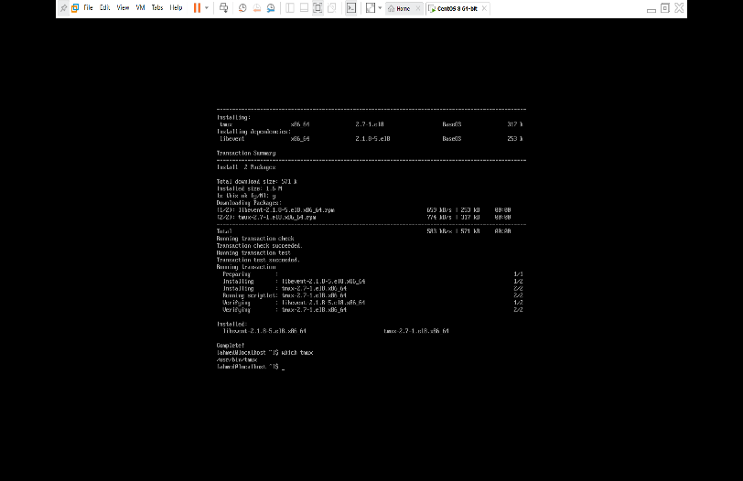

1. Install emacs
   1. Overview

Emacs is text editor that give so many powerful features to edit files, for example auto correct spelling mistakes and even given a different color to your text that’s why emacs is a best tool for programming.

* 1. Installation setup
* First, we check if we have the emacs package in our local repository by typing the command blow:

Sudo dnf search emacs

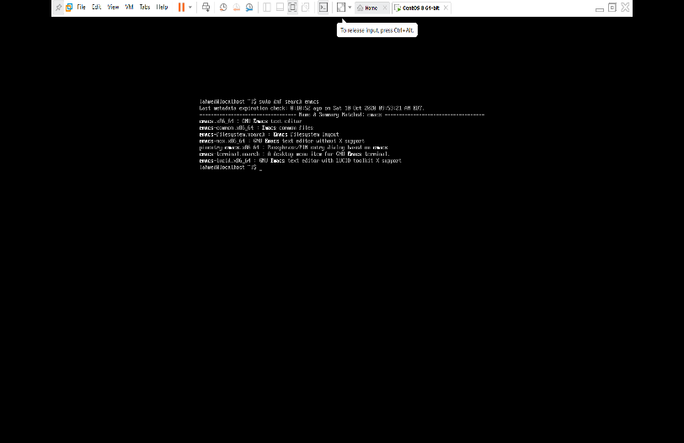

The emacs package is available.

* Second start the installation by typing the command blow:

Sudo yum install emacs

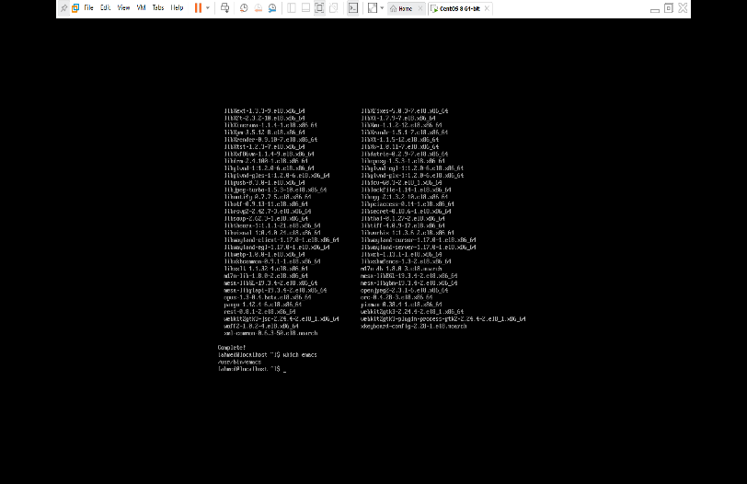

Here they give the summary of the package type yes to continue

* After the installation is done will check the location of the installed file by typing the command blow:

Which emacs

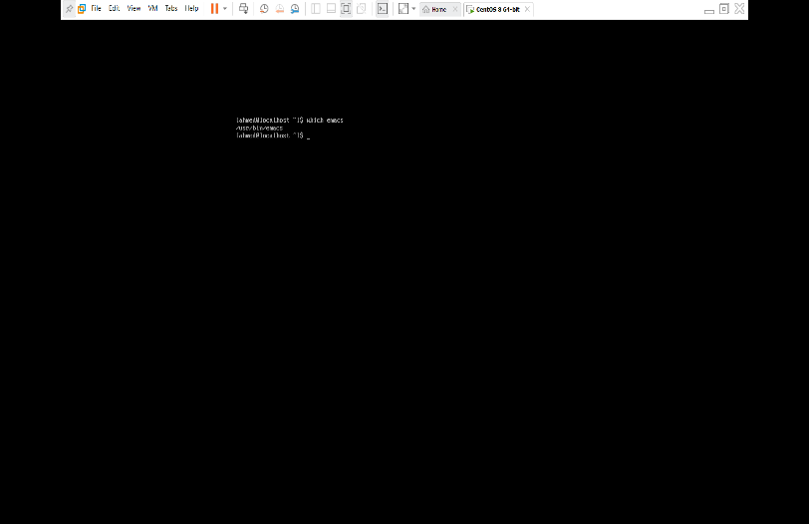

1. Install Fail2Ban
   1. Overview

Fail2Ban is used to controller and analyses the log in to your server given the protection against brute-force attacks.

* 1. installation setup
* First, we check if we have the Fail2Ban package in our local repository by typing the command blow:

Sudo dnf search fail2ban

The fail2ban package is not available so we need to add the corresponding repository.

* Fail2ban package correspond to the epel repository, so install it we type the command blow:

Sudo yum install epel-release

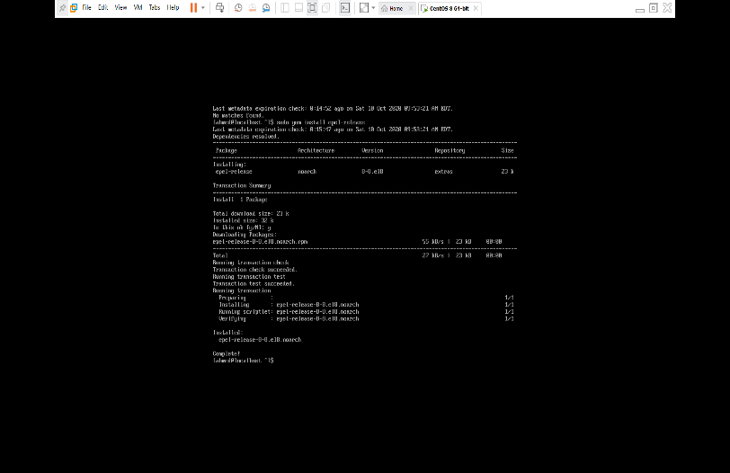

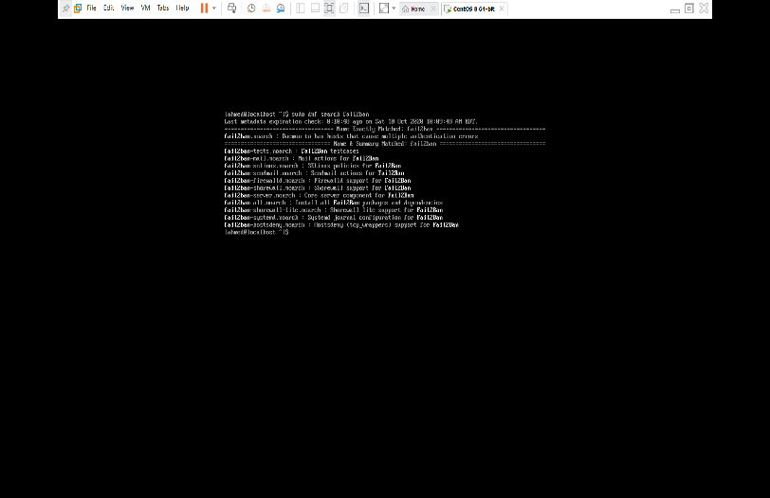

Fail2Ban package now is available in our local repository

* Now we can start the installation by typing the command blow:

Sudo yum install fail2ban

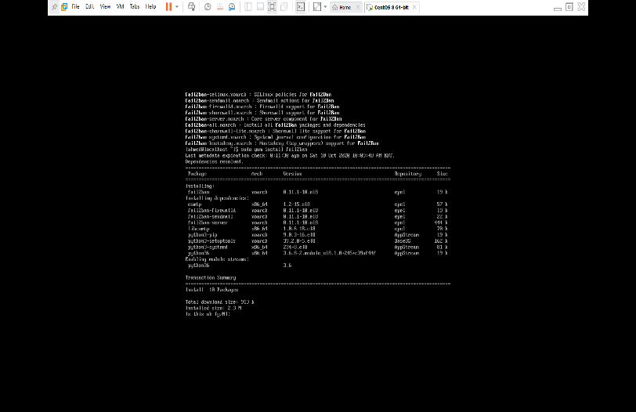

Here they give the summary of the package type yes to continue

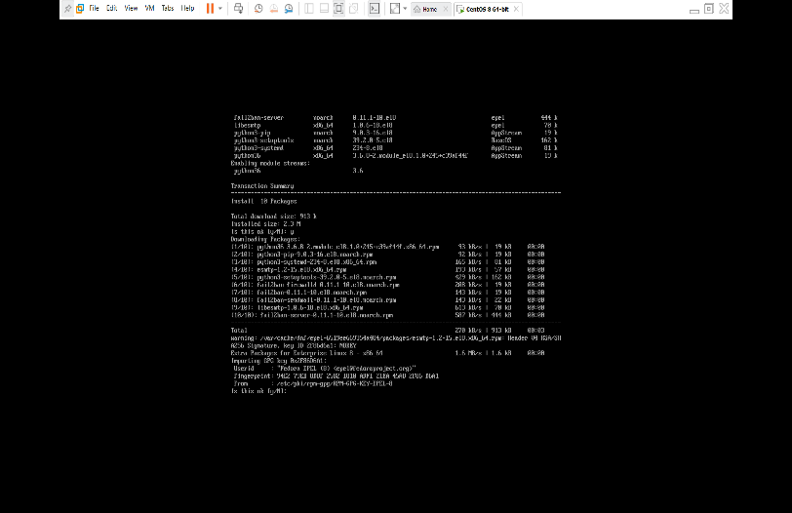

Here they give the GPG key details type yes to continue.

(GPG key is way to verify that the data of the software has not been change)

1. Install cowsay
   1. Overview

Cowsay is program that display a image of animals like cow with a message.

* 1. Installation setup
* First, we check if we have the cowsay package in our local repository by typing the command blow:

Sudo dnf search cowsay

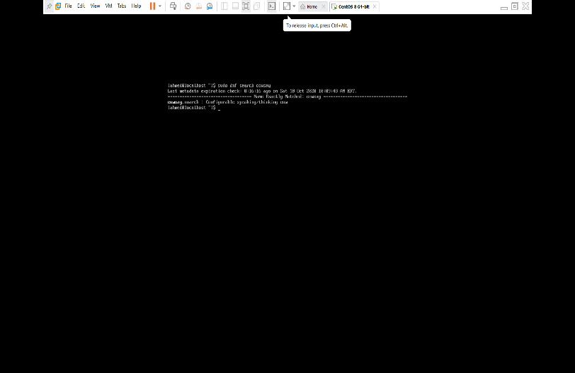

The emacs package is available.

* Second start the installation by typing the command blow:

Sudo yum install cowsay

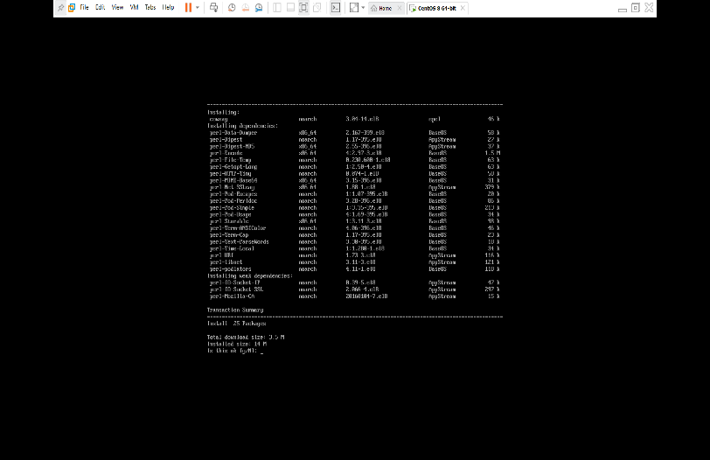

Here they give the summary of the package type yes to continue

* After the installation is done, we check the location of the installed file by typing the command blow:

Which cowsay

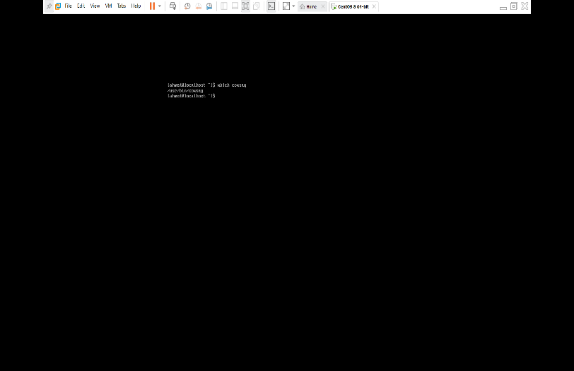

1. Install lolcat
   1. Overview

Lolcat is used to display any text file or out put with rainbow color.

* 1. installation setup
* First, we check if we have the lolcat package in our local repository by typing the command blow:

Sudo dnf search lolcat

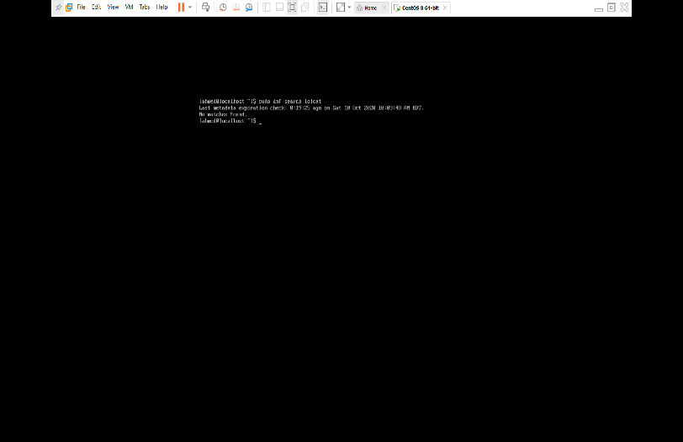

The lolcat package is not available so we need to add the corresponding repository.

* lolcat package correspond to the snap repository, so install it we type the command blow:

Sudo yum install snapd

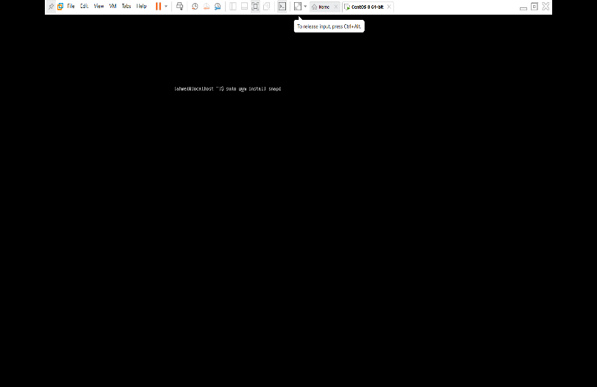

Then we need to enable the snap communication by typing to command:

sudo systemctl enable --now snapd.socket

to create a symbolic link between /var/lib/snapd/snap and /snap:

sudo ln -s /var/lib/snapd/snap /snap

then start the installation by typing the command:

sudo snap install lolcat-c

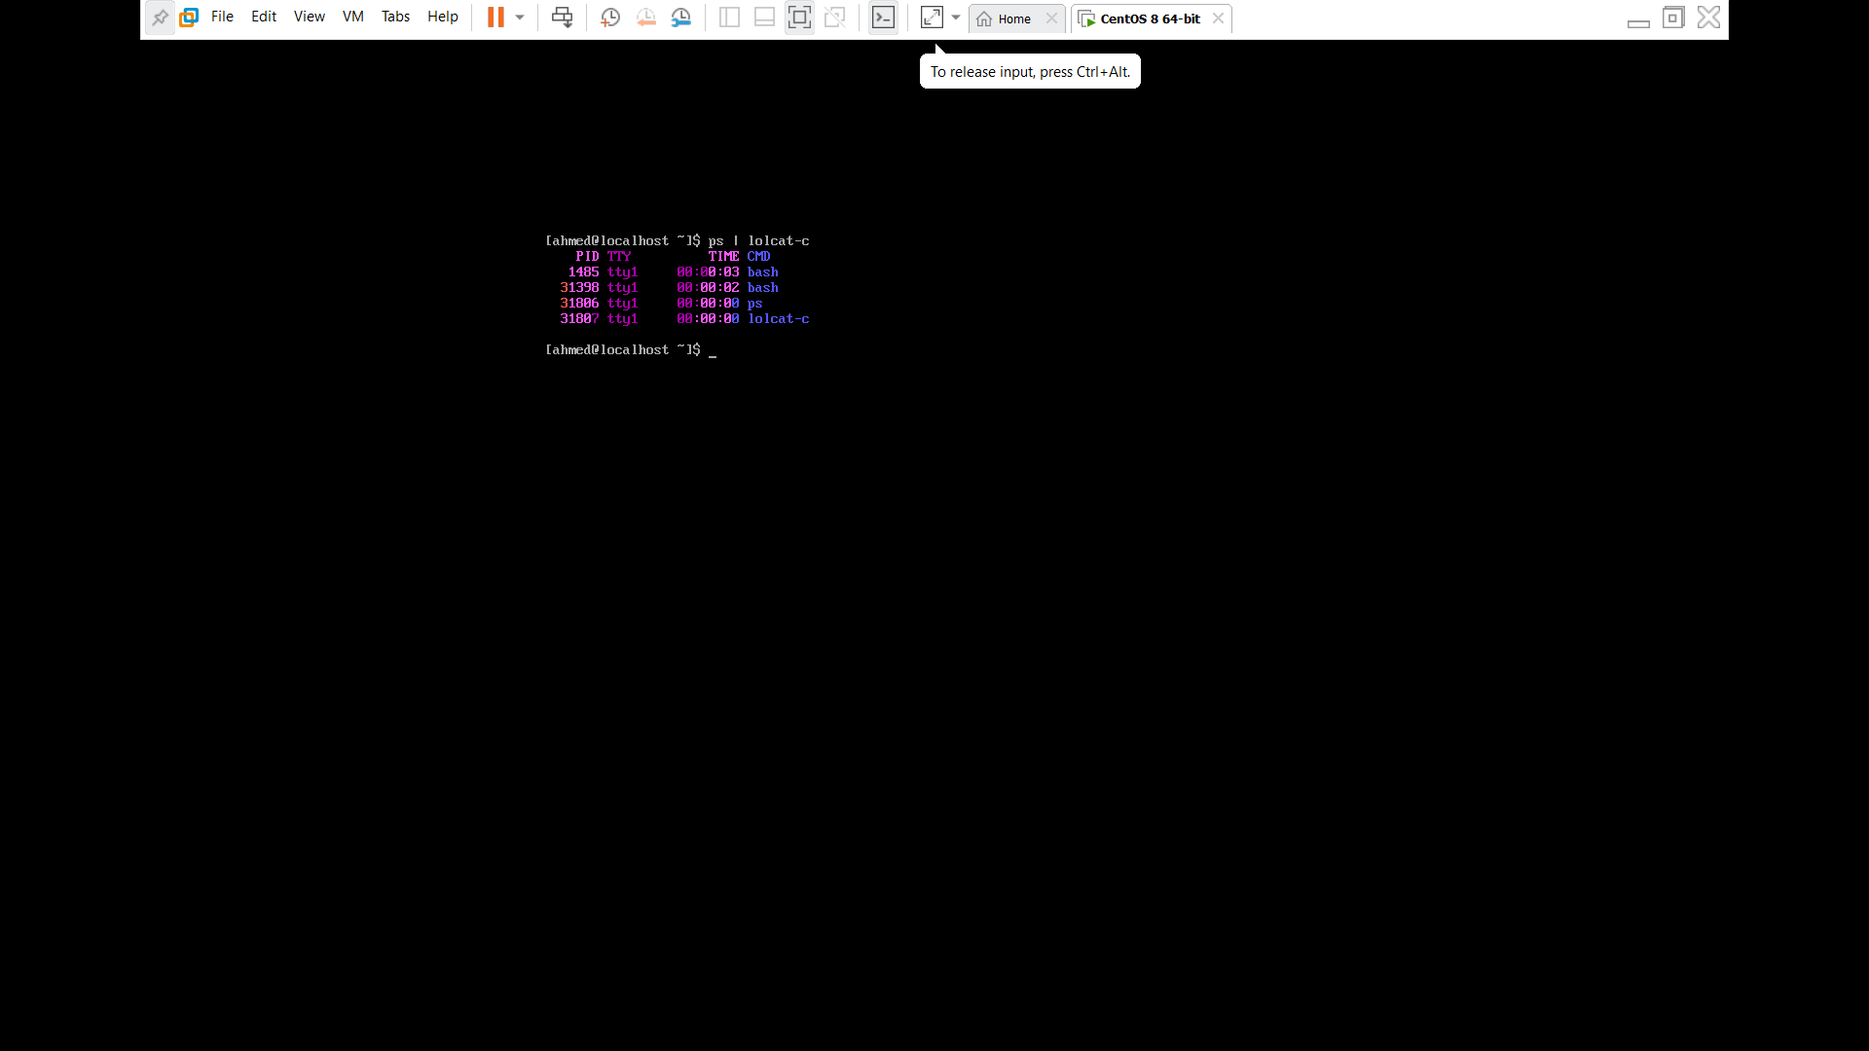

1. update vi to vim
   1. Overview

Vim is very known text editor in Linux environment, came with allot of approvement over vi for example flexible insert mode, visual mode, online help system, macros.

* 1. Installation setup
* First, we need to install vim let’s check if we have the vim package in our local repository by typing the command blow:

Sudo dnf search vim

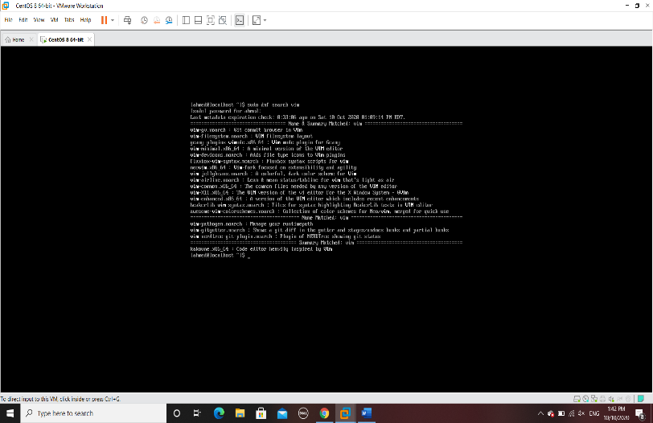

The vim package is available.

* Second start the installation by typing the command blow:

Sudo yum install vim

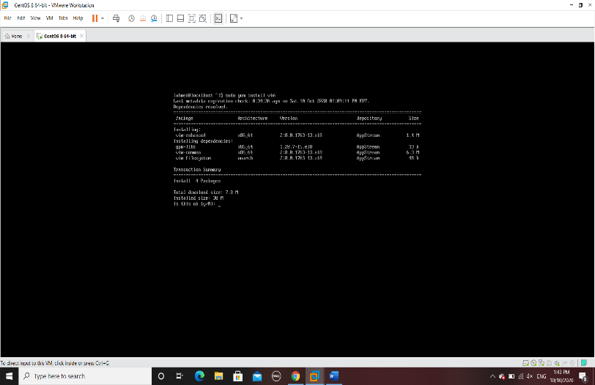

Here they give the summary of the package type yes to continue

* After the installation is done, we check the vim version:

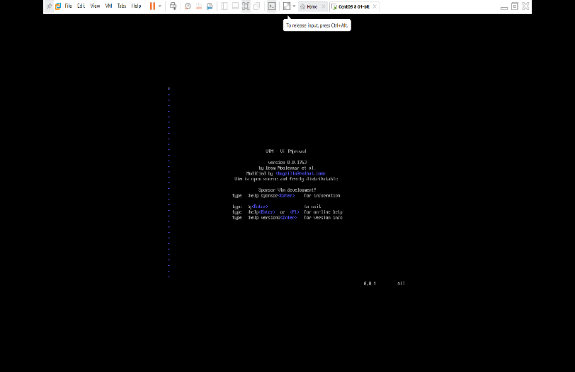

* After the installation is done, we check the location of the installed file by typing the command blow:

Which vim

